LAB REPORT

for
Lab Assignment #7:
LCD Display Controller & Clock

Table of contents:

1. Introduction………………………………………………………………….………..1

2. Design ………………………………………………………………………………..2

3. Functional Behavioral Requirements……………….………………………….…..2

4. Prototype Testing Plan…………….………….…………..…………….....………..2

5. Result of Testing…………………………………………………………………….3

6. Answer To Questions…...………………………………………………….………..3

……………………………………………………………4

……………………………………………………………5

7. Conclusion………….……………………………………………………….………..6

1. Introduction

“In this assignment, students will create a modular sequential logic design using VHDL
finite-state machines to design & implement a controller for a real-world peripheral
device of non-trivial complexity (a 2-line by 16-character liquid crystal display,
Crystalfontz CFAH1602B-TMC-JP). The controller implementation must respect all of
the signal timing constraints that are specified in the device datasheet (if it does not, then
points will be deducted even if the design happens to work anyway). Once the controller
is implemented, it must be used to display the team members’ names and the current real
time (from lab #6) on the LCD. This assignment is to be carried out as a structured
design process. Students should design and test their circuits at home in the simulator,
and then test their designs in lab on the DE2 boards.”
-- quoted from Lab Assignment #7 document.

2. Design
See question 5 for the VHDL Design
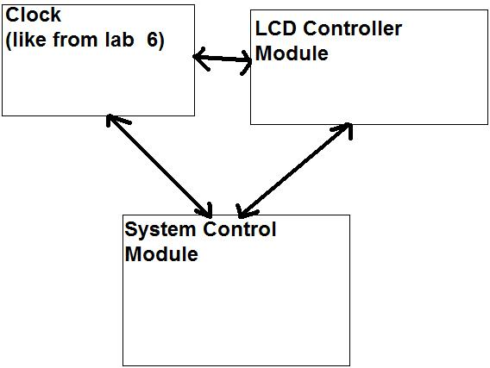

3. Functional behavior requirements

System-level functional requirement #1. Control over the LCD unit.

System-level functional requirement #2. Displays the team members name on one line and the time on the next.

4. Prototype testing plan
The testing procedure consists of the following steps:

- Turn the DE2 board on. The initial time should be 12:00:00 (like our clock from lab6).
  - There will be no use of KEY’s to increment time.

2. The first line of the LCD show display “Jeff Kitchen” and “Paul Kafka”

3. The second line of the LCD show display the time.

5. Result of Testing
During the lab session, we couldn’t get the LCD to display anything. The clock module hooked up to the HEX displayed, but the LCD didn’t. We decided the problem was probably the initialization. WE kept changing the initialization component and still not output displayed. We then made the initialization as a process instead of a component, and sill no output displayed.
We came back the next day with a new VHDL design. We finally got output to the LCD display, except the output was not correct and very random. After hours of tweaking, we got it to finally output correct. We noticed that there was a small variation of delay comparing the HEX output and the LCD output. Also, the am, pm wasn’t rolling over. We then fixed a couple things and retested it. It worked!

6. Answer to Questions

Question #1
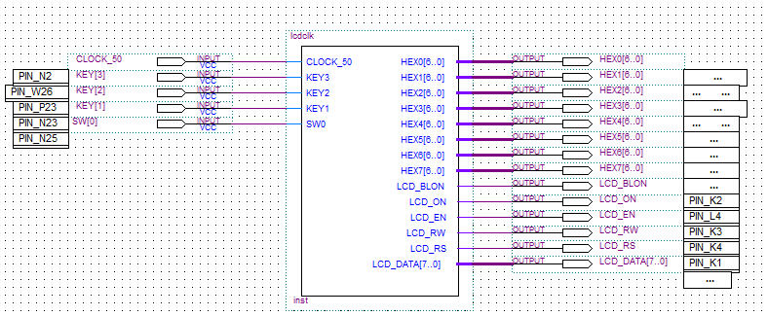
The Clock Module needs to include AM/PM.
The LCD Controller Module accepts LCD commands to be executed, sends commands to the LCD with respect to timing controls, and outputs a clock-edge when it is ready to process the next command.
The System Control Module waits from different components of the time to change, and sends the LCD controller the sequence of commands need to update the display.

Question #2
The clock on the DE2 board will be used for time reference to 50 MHz. The faster the clock, the better (maximum) performance.

Question #3
The inputs and outputs are as follows for the FSM:
Clock_50 : IN STD_LOGIC; -- inputs a clock
LCD_D: OUT STD_LOGIC_VECTOR(7 DOWNTO 0); -- Outputs buss to lcd
LCD_WR : OUT STD_LOGIC; --output read when high. write when low
LCD_EN : OUT STD_LOGIC; -- chip enable signal
LCD_RS : OUT STD_LOGIC; -- Instruction code
LCD_ON : OUT STD_LOGIC; -- lcd on

Question #4
Top Level design.
- Initialized the LCD
- Send sequence of characters
- Write colon between parts of time.
- Use static loop to check for different components of the time to change.
Question#5
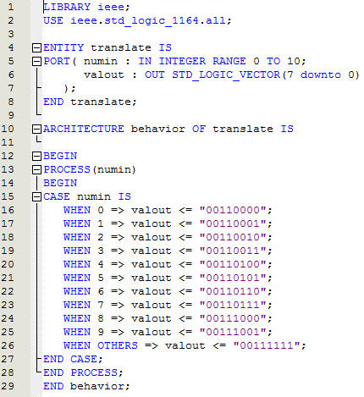
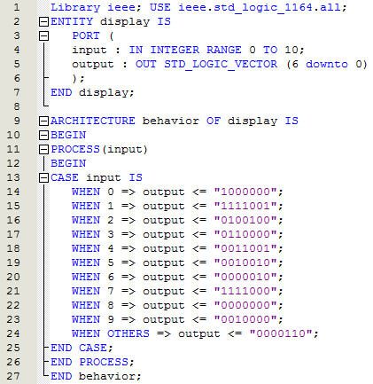
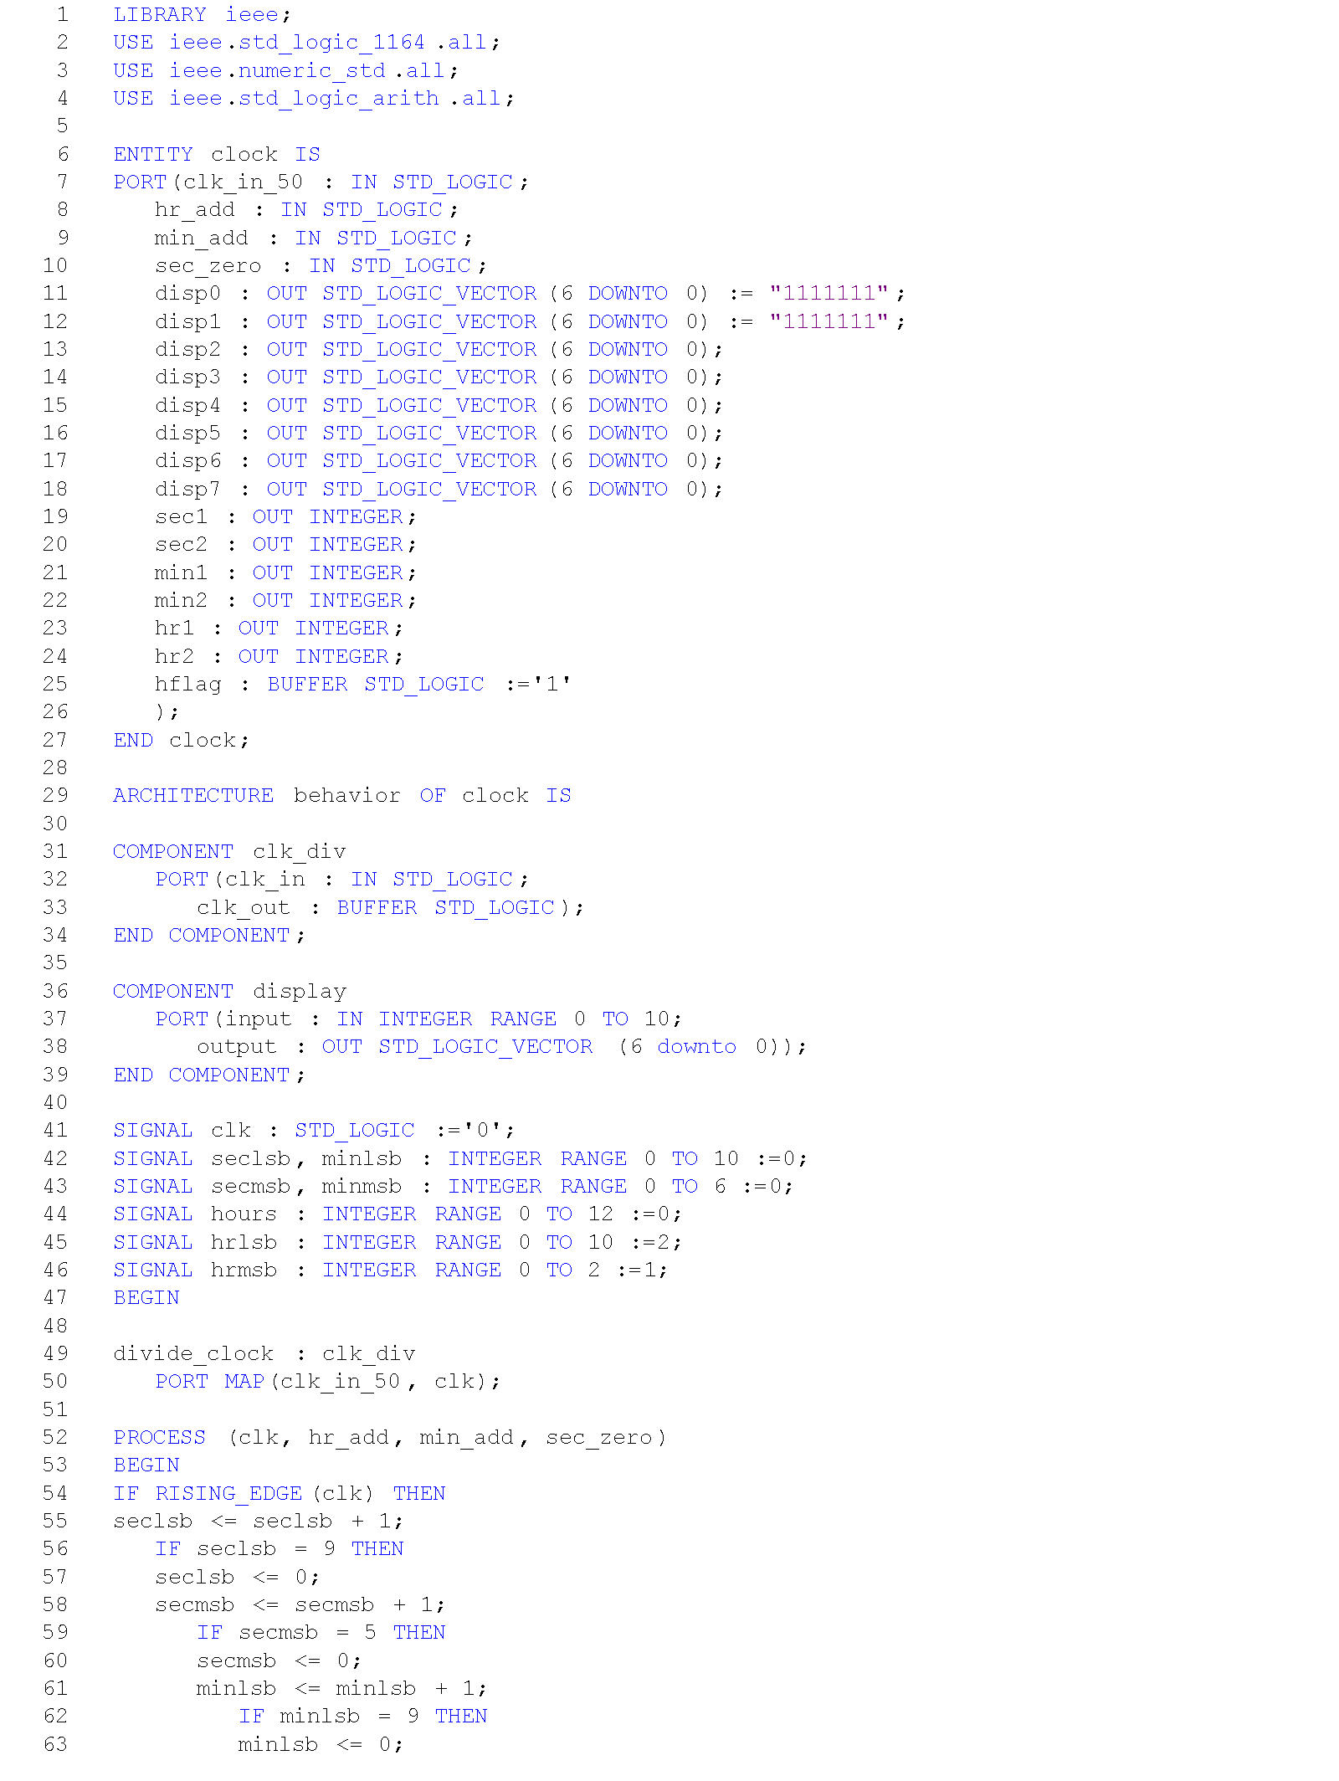
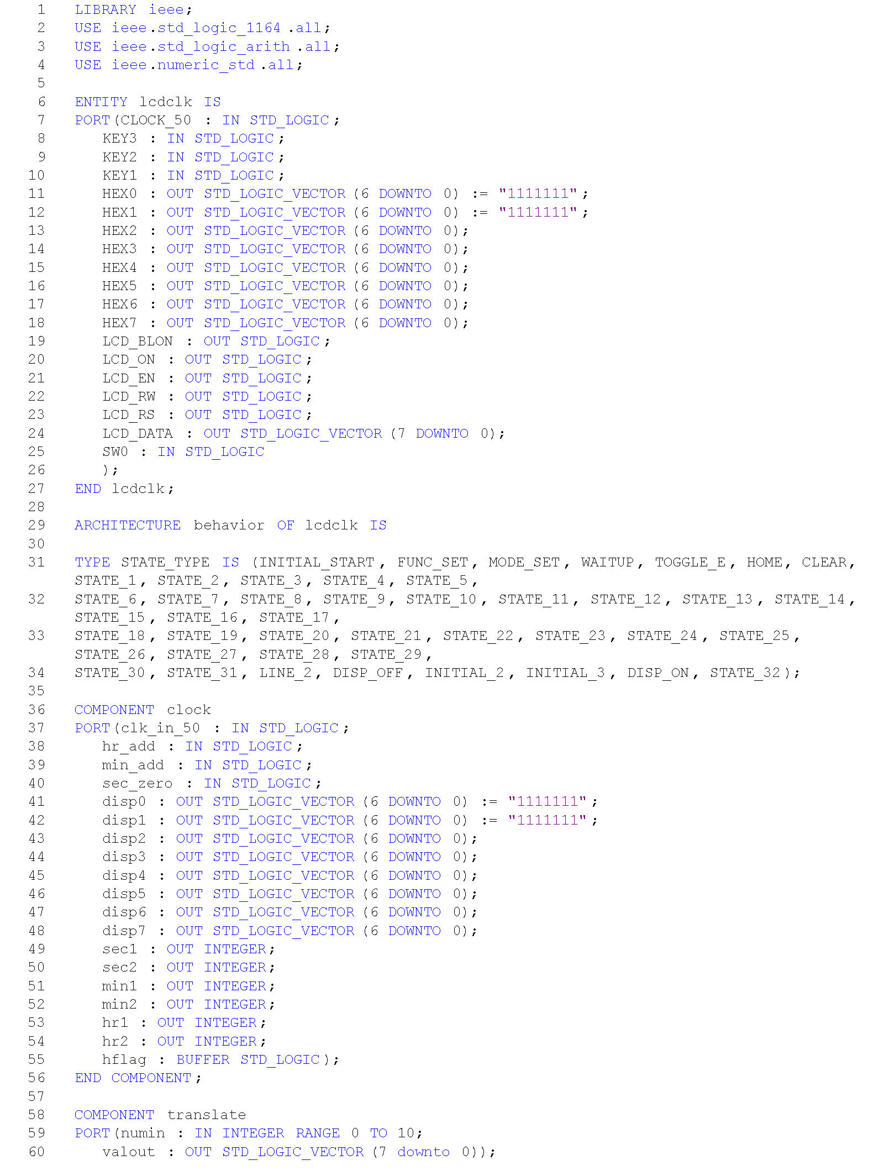
The code above are all the components and main VHDL file. Warning: Not all the code is shown.

Question #6
The testing procedure consists of the following steps:

- Turn the DE2 board on. The initial time should be 12:00:00 (like our clock from lab6).
  - There will be no use of KEY’s to increment time.

2. The first line of the LCD show display “Jeff Kitchen” and “Paul Kafka”

3. The second line of the LCD show display the time.

7. Conclusion
This assignment gave practice at design & coding of substantial modular sequential designs using finite-state machines (FSMs) written in behavioral VHDL. It also gave students experience interfacing with a real-world sequential peripheral device (LCD panel) with a serial/parallel control interface. Another thing it gave students was practice at programming, simulating, and debugging substantial-sized modular sequential HDL-based designs using the Quartus tool. Lastly, this assignment continued exercising students’ ability to go through a structured design process with all appropriate documentation.

